Figure 2.1: Initial Scatter Plot (Uncleaned Raw Data)
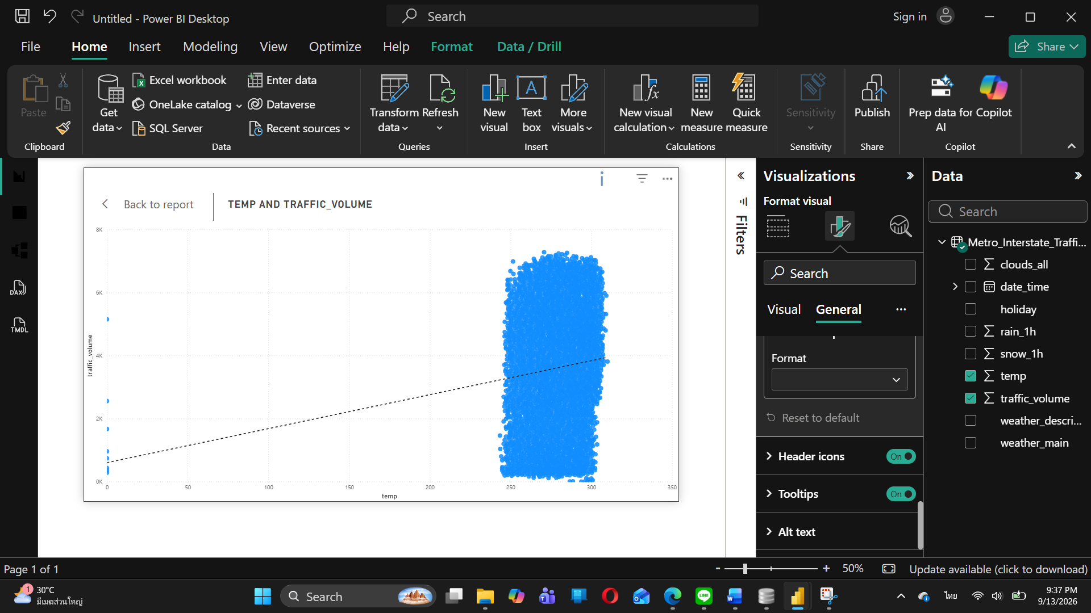
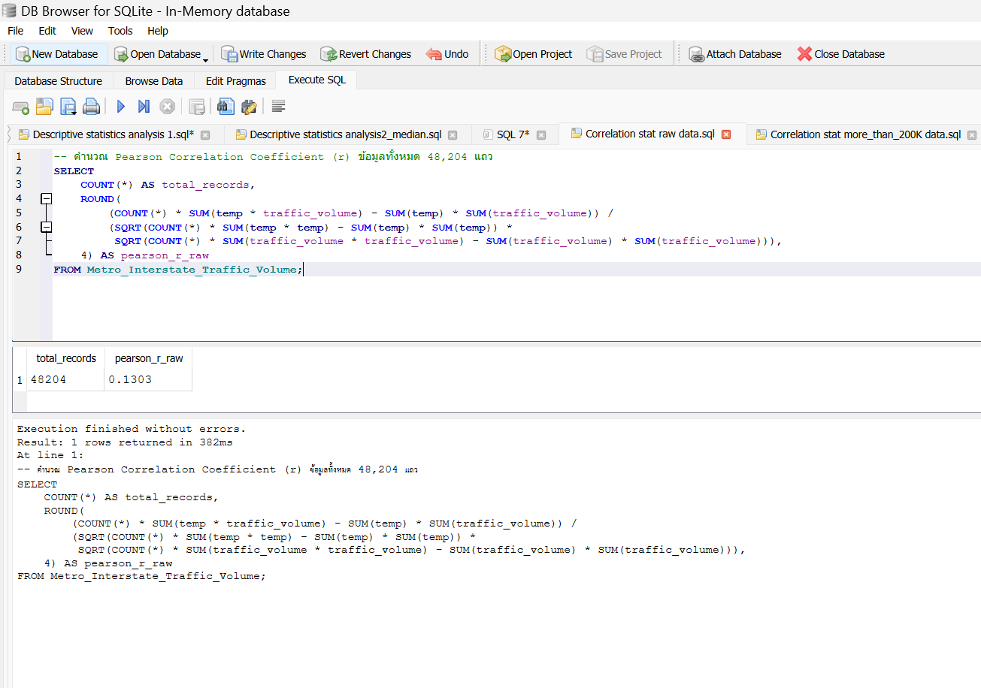

Figure 2.2: Refined Scatter Plot (Filtered Dataset: temp > 200 K)
